Day 9 – 2 Apr 2024

Spring Framework or Adv Spring Framework

40 hours training

Spring boot, Spring reactive modules, spring web client, spring with hibernate.

Spring transaction management, spring security etc.

<https://start.spring.io/>

Reactive Programming

If we create Spring MVC rest api using Java. Whenever any client send the request to us. They request can be block. Because java is thread based programming language.

Reactive programming provide a features non blocking mechanism

Mono

Flux

Reactive programming depends upon Observable design pattern.

Mono and Flux provide as Observable objects with subject can be string type, integer type, float type etc.

To consume that data in frontend side technology we use subscribe

Which takes 3 parameter

1st to load the data.

2nd if any error generate which loading data

3rd after completed.

Creating simple spring reactive api

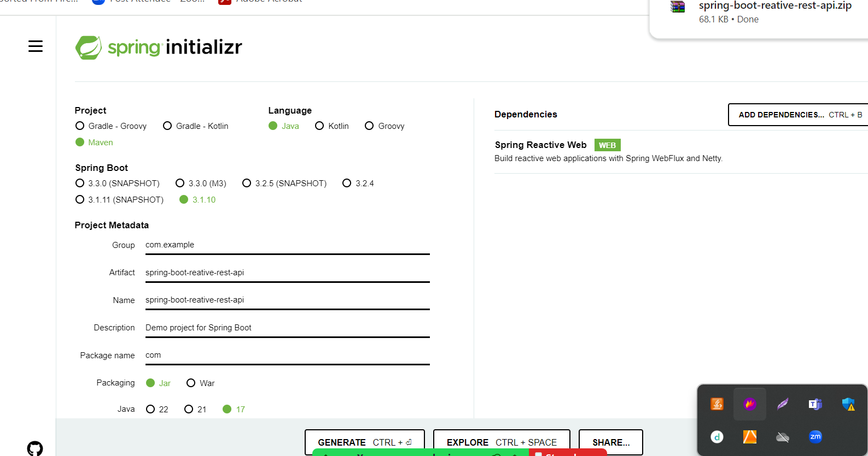

RestTemplate Vs WebClient

Using RestTemplate we can consumer normal rest api develop using any language like jax_rs, spring boot or any other technologies.

WebClient : generally use to consume reactive rest api.

Spring security

Using Security we can provide authentication as well as authorization.

Authentication: if we want to access any resources like access rest api, open dashboard, we need login using login details.

After authentication base upon roles we need to provide we need to allow the user to access specific resources.

Before spring boot if we want to achieve security. We were doing all security configuration using xml file.

We were downloading all required dependencies.

After spring boot spring framework provide security starter to achieve basic security features.

Spring 1.x boot

Spring 2.x boot

Spring 3.x boot

Creating simple spring boot basic security

Web starter and security starter

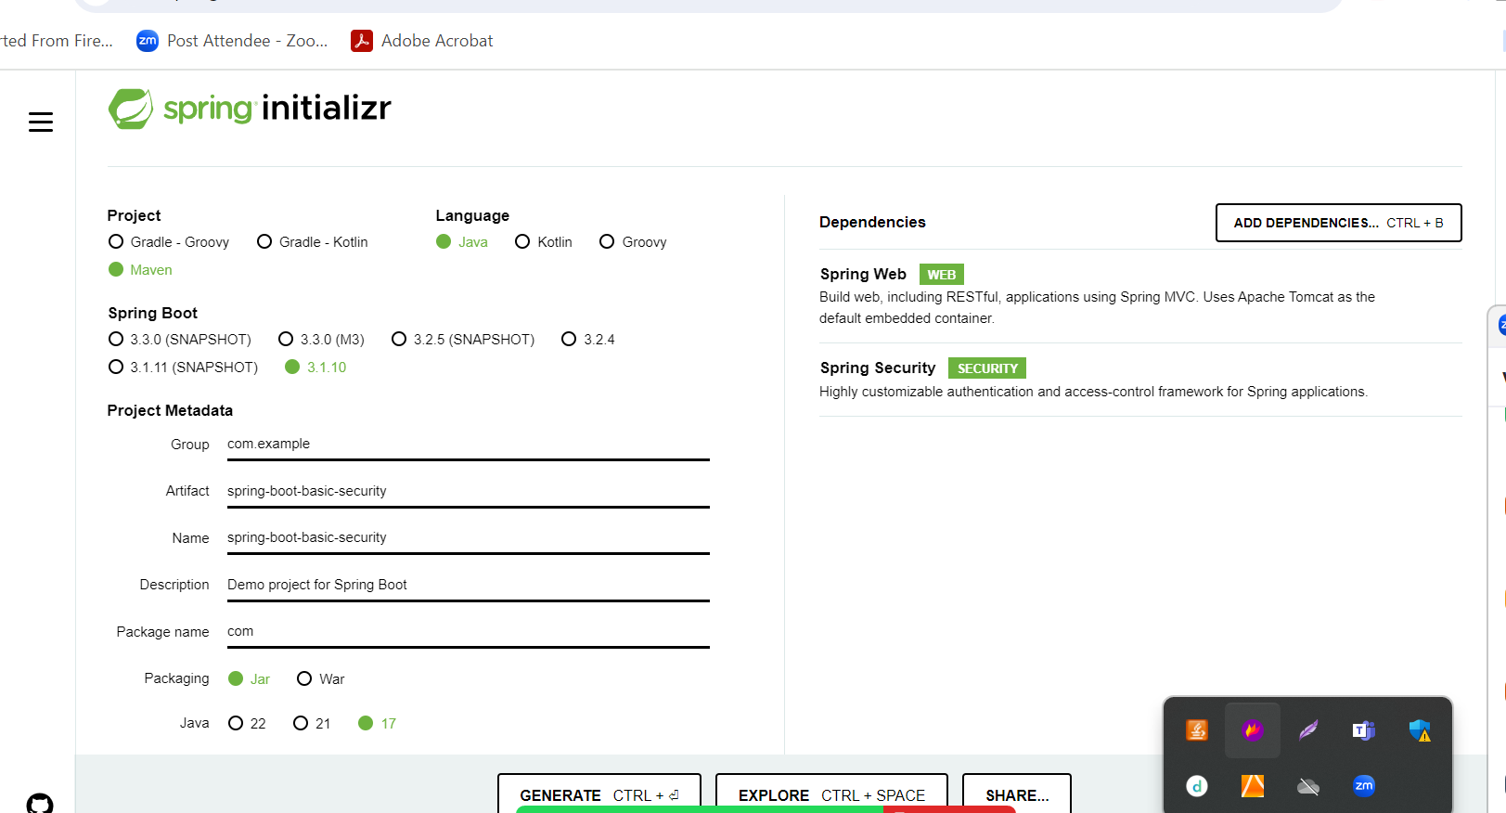

By default spring security provide username as user and password random password.

If we need custom password

1. In application.properties file we can writer username and password.
2. Using normal java classes ie configuration classes.

We need make normal java class with @Configuration as well as @EnableWebSecurity annotation.

Spring security provide core interfaces

UserDetailsService and UserDetails this interfaces holds user details.